

The Lighthouse
Zion & Trinity Lutheran Churches
950 Huron
St. Ignace, MI 49781

Address Service Requested

Nonprofit Org.
U.S. Postage
PAID
St. Ignace, MI 49781
Permit No. 55

,

The Lighthouse
Zion & Trinity Lutheran Churches
950 Huron
St. Ignace, MI 49781

Address Service Requested

,

Nonprofit Org.
U.S. Postage
PAID
St. Ignace, MI 49781
Permit No. 55


THE LIGHTHOUSE

Newsletter for November 2018

Light is shed upon the righteous and joy on the upright in heart. Psalm 97:11

Message from our pastor

Dear Brothers and Sisters in Christ,

The days are getting shorter and cooler, the last of the maple leaves are falling off the maple tree outside in the parsonage yard. For me looking at the fall colors, and feeling the chill in the air means one of my favorite holidays is rapidly approaching, Thanksgiving!

I can taste it now a moist turkey, cranberries, my mom’s sausage stuffing, mashed potatoes and gravy, being from Iowa you have to have the buttered corn, and then to top it all off pumpkin pie. Then of course there is that blessed time in the comfy chair falling asleep watching the football game! But there is something more important than the food and football, for almost 10 years Catherine and I have hosted thanksgiving for my family, together we get up in the wee hours of the morning and begin the preparation of the food, and we both loved it, and why we loved it is pretty simple, and that is to serve the people we love. Everyone gathered around the table, is something that warms our hearts, and for this we truly give thanks.

There is something about the breaking of bread that is very special, we see it throughout the bible from the Old Testament to the New Testament, it’s that coming together and giving thanks for all that we have been given that makes it special. God has given us so many gifts, and it’s wonderful to share them with everyone. As Christians we really do celebrate Thanksgiving every week when we come to the Lord’s Table for communion, where all are welcome to taste and see that the Lord is good. It’s doesn’t matter if you’re a long time member of the church family, or someone who is just passing through. I have had numerous phone calls from out of town people asking if we are having communion on Sunday. In one of those phone calls the gentleman asked me if all are welcome. It brought joy to my heart to tell him yes. And when he asked “Are you sure?” my smile got even bigger when I told him “yes I am” because I am the Pastor! God welcomes all, without judgment, to the table. It is in that bread and wine where all of our sins are forgiven, through Christ’s precious body and blood. It is given so freely for us, even though we fall short, to the glory of God. For that I am truly grateful!

I want to wish you all a very blessed and Happy Thanksgiving!

Yours in Christ,
Pastor David

All Saint’s Day

November 1st is All Saint’s Day. This is a day in the church when we remember all the baptized who’ve gone before us. In the past year, we have buried the following saints:

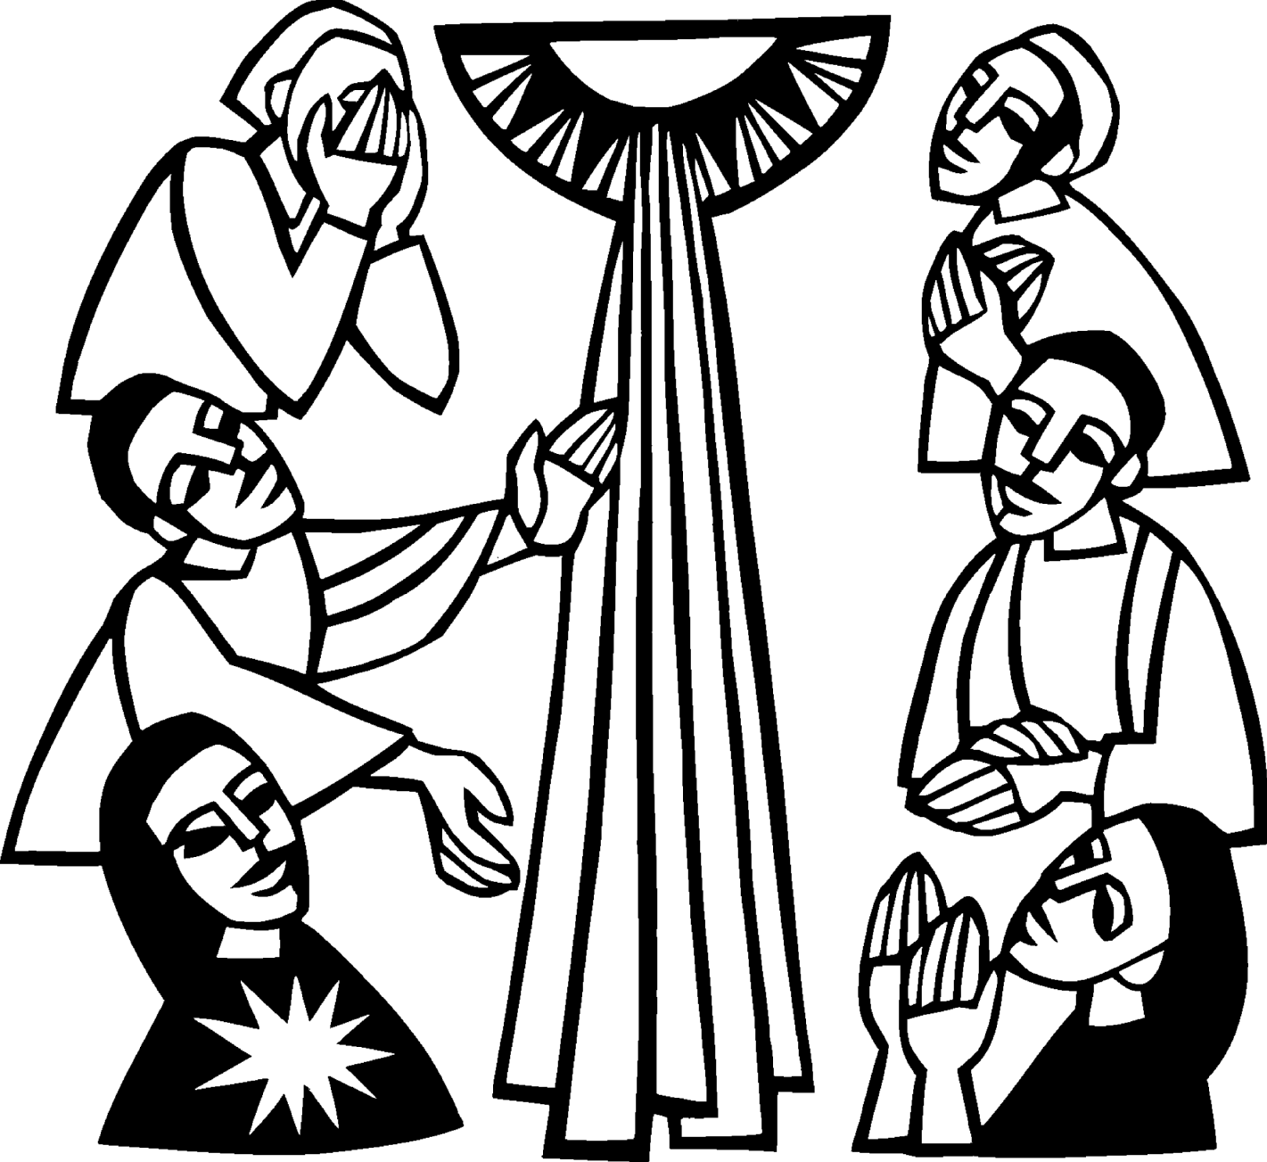
Nadine Dandona
Jerry Fenlon
George Garen
Chester Sayles
Michael Lehto
Carol Richel
Nancy Hardy
Linda Wilkins

Carol Richel Memorial Service

A memorial service will be held on November 3rd at Zion. Visitation at 10 am, service at 11 am. There will be a lunch to follow.

Newsletter

The November Newsletter was sponsored by
Susan Simpson

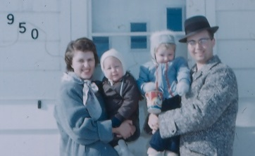

In honor of her parents
Rev. Phil & Joan Anderson
(Phil was pastor here from 1954-1964)

Noisy Offering

The November Noisy Offering will go to Mackinac County Children’s Toy Drive.

Adult Bible Study

Trinity Bible Study will be Tuesdays at 6 pm.

Calendar Note

Daylight Savings Time changes on November 4th. Turn your clocks back. Smoke detector batteries should be replaced at least once a year. People often change them when the clocks change.

Women’s Group

On November 12th, the Ladies of Zion will be providing the meal for the Lion’s Dinner. Sign-up will be at the church on Nov 4th and 11th.

Confirmation

Confirmands are to go to Community Thanksgiving Service (see below).

Community Thanksgiving Service

The Community Thanksgiving Service will be at Zion Evangelical Lutheran Church on Sunday, November 18th at 7 pm. All are welcome to join us in giving thanks for all of our blessings.

Advent is Coming!

We will be decorating the church for Advent, following the service on Sunday, November 25th. Please help out if you can.

Anniversaries in November

November 30 David & Catharine Tielbar

Birthdays in November

November 3 Tim Idalski
4 Ernie Vallier
4 Linda Wilkins
7 Rita LaVake
11 Kathy Marshall
11 Samantha Wyers
12 Shirley Winberg
15 Nancy Hardy
15 Alicia LaLonde
17 Faith Gaubault
17 Wyatt Huhn
17 Kyra Spencer
18 Lori Wilkins
19 Connie Olsen
19 Justin Stenson
22 Lisa Gamble
23 Shirley Campbell
25 Dawn Akers
26 Misti Gamble
29 Jessie Rogers

Baptismal Anniversaries

November 2 Joshua LaJoice
November 12 Misti Gamble
November 13 Tim Idalski
November 14 Adrian Coleman

November 14 Madison Coleman
November 17 Kristen Olsen
November 21 Duane Gamble
November 25 LaRoy Hill
November 27 Mike Wilkins
November 27 Mandy Bowlby

Evergreen Living Center

Barb Lehto

Castle Rock Retirement Center

Judy Ryerse

Trinity Worship Families

Nov 4 Kennedy Family
Nov 11 Rose Family
Nov 18 Movalson Family
Nov 25 Baron Family

Zion Funeral Committee Oct - Dec

Team Leader: Lorraine Graham (643-8419)
Co-leader: Betsy Turf (643-1512)

Servants for Zion

Ushers & Greeters

Nov 4 Nicole Garen Family
Nov 11 Sam LaVake Family
Nov 18 Dena Barker & Lori Wilkins
Nov 25 NOIZ

Lectors

Nov 4 Dawn Akers
Nov 11 Sandy Feleppa
Nov 18 Lynn Evans
Nov 25 Fred Feleppa

Communion Assistants

Nov 4 Tammy Shepard
Nov 11 Emma Feleppa
Nov 18 Steve Christiansen

Acolytes

Nov 4 Josh Feleppa
Nov 11 Brendan Insley
Nov 18 Gunnar Olsen

Altar: Cathie Tielbar
Money Counters: Susan Fenlon & Lorraine Graham

The Usher duties are:
- Arrive 30 minutes before church
- Pass out bulletins and welcome guests
- Help with the offering and communion
- Record attendance

Council Meetings

Trinity Council –November 13, 2018 – 6 pm
Zion Council – November 14, 2018 – 6:30 pm

Zion’s Council Members
President: Steve Christiansen 298-1051
Vice-President: Carol Elmblad 630-4380
Co-Treasurers: Dawn Akers 643-7552
Co-Treasurers: Lana Lennington 643-6576
Mary Christiansen 235-6123
Robert Marshall 643-8936
Secretary Dena Barker 430-1460
Emma Feleppa 430-8011
Tammy Shepard 906-984-2064

Trinity’s Council Members
President: Jerri Rose 292-5570
Vice-President Sharon Chalmers 292-5440
Secretary: Tracy Movalson 292-5581
Treasurer: Pega Kennedy 292-5633
Co-Treasurer: Jim Rose 292-5570
Financial Secretary: Tom Gustafson 292-5460
WELCA: Pega Kennedy 292-5633
John Kennedy 292-5633
Lois Movalson 292-5581

Zion Women’s Report

 | Checking Balance | 2,351.12
11/6 | Lions dinner | 200.00 | 2,551.12
11/14 | Lions dinner | 200.00 | 2,751.12
12/4 | Donation | 20.00 | 2,771.12
12/8 | St Ignace News craft ads | -38.00 | 2,733.12
2/5 | Paper plates/napkins | -34.78 | 2,698.34
2/22 | Newspaper soup ads | -12.00 | 2,686.34
3/5 | Donation | 50.00 | 2,736.34
3/29 | Paper plates | -21.16 | 2,715.18
5/16 | Dish washer soap | -83.29 | 2,631.89
5/22 | Donation | 60.00 | 2,691.89
8/17 | Graduation blankets | -66.00 | 2,625.89
8/24 | Garbage bags | -36.02 | 2,589.87
9/11 | Dish soap | -5.12 | 2,584.75
10/5 | Ham, buns, toilet soap | -30.77 | 2,553.98
 | 1 outstanding bill to Bentley's
 | Savings Balance | 1,512.80
12/4 | Craft show | 275.00 | 1,787.80
12/31 | Interest | 0.60 | 1,788.40
1/15 | Donation | 20.00 | 1,808.40
3/31 | Interest | 0.67 | 1,808.40
6/18 | Lions dinner | 200.00 | 2,009.07
6/30 | Interest | 0.68 | 2,009.75
9/10 | Lions snack | 50.00 | 2,059.75
9/16 | Lions donation | 10.00 | 2,069.75
9/30 | Lions dinner | 200.00 | 2,269.75
9/30 | Interest | 0.77 | 2,270.52
10/5 | Hardy donation | 300.00 | 2,570.52
10/17 | Donation | 30.00 | 2,600.52
 | Checking 10/17 - 10/18 | 2,351.12 | 2,553.98
 | Savings 10/17 -10/18 | 1,512.80 | 2,600.52
 | Totals 10/17 - 10/18 | 3,863.92 | 5,154.50

Zion Lutheran Church

Council Notes for October 24, 2018

Council Members Present: Pastor Dave, Mary, Steve, Bob, Dawn. No Quorum

Steve called the meeting to order at 6:37 p.m.

Pastor opened with devotions and prayer.

A. Pastor's Report:
1. We discussed the trouble we have had with the current copier. Pastor has a quote for a rental replacement for $125 per month that includes service and black toner replacement. Those present supported pursuing the rental, Council will meet briefly after church on 10/28 to approve, since we didn't have quorum at this meeting.

B. Treasurer's Report:
1. Dawn presented the Treasurer's report and we are still in need of increased revenue. Average collection per week is $700.00 and we need to average $1100 to $1200.00 per week. We will need to tap into the 2nd $5000 in the Endowment Fund monies that were approved for use at the summer Congregational meeting if things don't improve. Stewardship pledges have gone out and Council will monitor the results of those pledges.

C. Secretary's Report:
1. No report was available for review.

Old Business:
1. Bob is working hard to get the lights replaced throughout the Church, as well as the fans. Priority is the lights up front, Pastor and Dawn are having a hard time seeing. Bob reported Belonga's fixed the furnace in the Family Center, and the water heater in the parsonage is fixed.

2. " Breathing New Life into Old Bones" meeting with the Synod has been re-scheduled to January 11 (evening) and January 12 (morning). We will need 10 church members to attend this event, please see Pastor, Lorraine or a Council Member if you are interested.

New Business:
Next Church Council Meeting: November 14, 2018 at 6:30 pm.

Meeting was adjourned at 7:20 p.m. following the LORD'S Prayer.

Respectfully submitted: Mary Christiansen

Trinity Lutheran Church Minutes

October 23, 2018

Present: Pastor Dave, Jerri and Jim Rose, Pega and John Kennedy, Tracy Movalson, and Tom Gustafson

Meeting began at 6:13pm

Opening: Pastor read Matthew 7, 13-14. Narrow and Wide Gates

Pastors Report Will not be in church this Sunday. Celebrating the 120th anniversary of church where he did internship. Had another funeral.

Secretary’s Report was read and approved. No report

Treasurer’s Report was read and approved.

Financial Secretary’s Report was read and approved.

Old Business:
Get mailing started for getting funds for Altar painting

New Business:
Ken Katz, the conservator will be here Saturday, October 27 to appraise our painting. He will also go to Zion in Allenville.
Pega read correspondence from Warburg-Thank you. Pastor Bre moving to Marquette. Ask for donation to Loryce M Dyer Hospice. Tom motioned we donate, Tracy supported. Approved
Mackinac County toy drive progressing. We are donating scarves, hats and mittens, socks, toys.

Meeting adjourned at 7:52pm
Respectfully Submitted, Tracy Movalson
Secretary

Prayer List

If you would like someone added to the prayer list, please fill out a yellow card or call the church)


Mary Belonga, Dave & Lois Movalson, Barb Lehto, Bev Kammers, Eunice Therrian, Craig Therrian, Shirley Winberg, Richard Galor, Judy Ryerse, Cindy Hendricks, Carol Litzner, Holly Lester, Sandy Huskey, Jim & Jerri Rose, Bill & Sandy Tielbar, Walter & Jane Puccio, Carol & John Watson, Mike Wilkins, Larry Hopper, David Lloyd, Donna Harju, Tom Beaudoin, Terri Hill, Merlin Doran (Merlin’s father), Gayle Kaminsky Pande, Ann Blaine, Mary Ellen Reavie, Sylvia Richards, Krista MacArthur, Bill & Ann Anderson, Pastor Joe, Sam, Dorothy Pechta, Chase Hancock, Jerome Robbins, Jack & Elsie Dryer, veterans with PTSD, Ed Heenan, John Latta, Lloyd & Marion Steiner, Levi Thompson and the families & friends of Linda Wilkins and Wes Pechta

~~~

A man is rich according to what he is, not what he has.

From the Bishop

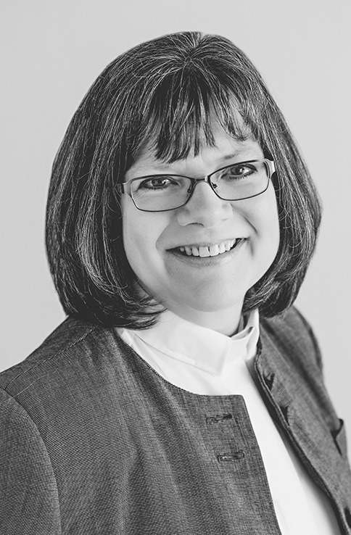
‘Therefore I tell you,
do not worry about your life, what you will eat or what you will drink,
or about your body, what you will wear. Is not life more than food, and the body more than clothing

When I read this in Matthew, I think back to a song that was popular a few years ago. It had a sort of Jamaican beat, and the singer sang over and over again, “Don’t Worry, be Happy.” And whenever I heard it, I thought of palm trees and the blue ocean, and drinking something cool and fruity on a white sandy beach. This song speaks about worry as if we can just turn it off, check out from life, distance ourselves from all our cares and concerns and feelings and live as if life didn’t matter.

At Thanksgiving, we give thanks, because life does matter. The cares and concerns and feelings we have speak to how invested we are in living a life that matters. As we eat too much pie and turkey, we give thanks that we do not have to worry about what we shall eat or what we shall wear. We give thanks that life is more than food and clothing. We give thanks, that as much as God is involved in creation and feeding the birds of the air, making the lilies beautiful, causing grass and grain to grow, much as God is involved in all that is around us, we give thanks at how much more is God involved with that which is even more precious. As people of faith we take time to thank God for how much more God cares for you, provides for you, and gives you what you need the most.

Jesus says do not worry or be anxious, because Jesus knows how easy it is for us to get bogged down in the details. Of course food and clothing matter, but they only really matter if you don’t have any. I read the other day, about two Christian congregations. One is here in the U.S., and one is in Malawi. The congregation in the U.S. sent some folks over to Malawi for a visit and they saw first hand how the people struggled. The country was in the grip of a severe famine. People were barely surviving on what little they had, and yet worship was a priority, and the church in Malawi was full to busting on Sunday mornings. After the visiting group returned home, they continued communicating with this congregation in Malawi, and along with gifts of support, they sent a letter commending the congregation for their lively and thriving faith in the midst of such hardship. And they asked the question, “How is it that you have faith when you have so little?” And the people of the church in Malawi, sent back a letter of thanks, and their own question, “How is it that you have faith when you have so much?”

The congregation in the U.S. wondered how it was that the people from Malawi were not driven to despair. The people from the church in Malawi wondered how it is that having our basic needs met and then some, doesn’t lead us to trust in ourselves rather than God. It is a good question. It is easy to take what we have for granted. Having the food and clothing and shelter we need frees us to focus on what kind of food, clothing and shelter we want. And this can easily distract us from what really matters.

The people of the church in Malawi know first hand about faith born of desperation. But they are not alone in this. We know too that often it is out of need and desperation that we seek God. So often, it is a crisis that brings us to our knees. So often it takes an emptiness that we cannot name, or when life spins beyond our reach and we don’t know what else to do but pray. So often, faith comes when trust in God is all you have to go on. We are blessed when despair leads to hope in God. We are blessed when crisis brings us new understanding of God in our lives.

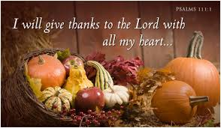
While there may be times when we come to God in desperation, how nice it is to come to God in praise and thankfulness for the many blessings we enjoy. At Thanksgiving and every time we worship, we gather to offer thanks to God, not just for food and clothing but also for the life we have that is so much more than food and clothing. We thank God for the wonderful gift of people we love and the blessing of people who love us. We thank God for all that God has made us to be and everything God calls us to become. But most of all, we thank God for giving us what we need the most, the saving power of Jesus the Christ.

Yours in Christ,

Bishop Katherine Finegan

Contact Information

Pastor David Tielbar may be reached at 906-984-2051 or at david.tielbar6@gmail.com. In an emergency, you can reach the Pastor’s cell phone at (563) 880-4512

Church telephone: 906-643-7870 - Answering machine
The secretary will usually be in the office on Tuesday and Thursday mornings from 9 – 12

The website is at http://zionstignace.com/home.html
- Find us on facebook at www.facebook.com/zionstignace

Email: ziontrinity950@gmail.com

Zion Evangelical Lutheran Church and Trinity Lutheran Church are congregations of the Northern Great Lakes Synod and the Evangelical Lutheran Church in America.

Trinity’s Sunday Service is at 9 a.m.
Zion’s Sunday Service is at 11 a.m.
Bake Sale

Sub & Bake Sale to benefit the Mackinac County Toy Drive at Family Fare, Saturday, November 3rd starting at 9 a.m.

Bowling with a purpose

Hello all. We have a great event coming up for youth of all ages and their parents. On Sunday November 4th from 2pm to 4pm we are holding our first annual “Bowling with a Purpose” event at Gateway Lanes/Fred's Pub in St. Ignace. We are hoping to put on a great event for our community's youth and parents. No alcohol will be served. Proceeds and donations go to our substance abuse and suicide prevention efforts in Mackinac County.

Tickets are $10 in advance and $15 at the door. In St. Ignace they can be purchased at Fred's Pub, The VFW, and B.C. Pizza. In Cedarville they can be purchased at First National Bank. You can also call/text Peter at 906-630-1208. If you wish to make a donation we will be accepting them at the event. Children three and under are free.

Tickets include:
Glow bowling and shoes
Burger, fries and pop
Glow Necklace
Crafts
Professional digital photos by Lindsay Vork http://vorkphotography.com/
Hot dogs for little ones

We hope that you can make it and bring your family and friends with you.

Vote!!!

November 6th is Election Day. Get out and vote!

Annual Turkey Dinner


The Annual Turkey Dinner & Craft Sale
sponsored by the United Methodist
Church will be on Thursday, November 8th,
5 – 6:30 pm at the LaSalle High School Cafeteria.

Veteran’s day

On November 11th, in honor of the 100th Anniversary of the end of the First World War, all the bells in town will be ringing at 11 am. There will also be a ceremony at LaSalle High School starting at 10 am. All are welcome.

Feeding America

The Feeding America food truck will be at Little Bear East on November 16th. Volunteers should be there at 9 am. Distribution starts at 11 am.

Bake Sale

The Mackinac Animal Aid Association
will be holding a bake sale at Family Fare
on November 17th starting at 9:00 a.m.

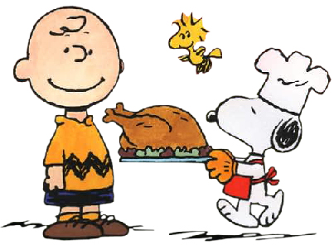

Give thanks
for family, friends and good food!

